33rd Annual North Central Regional Local Road Conference
8-28-18 draft – dch

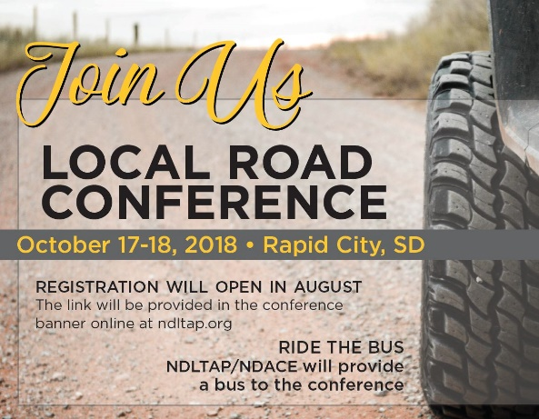
WEDNESDAY - OCTOBER 17, 2018
Moderator: Jennie Krause, KLJ
8:00 – 8:15 Welcome, Announcements & Introductions: Greg Vavra, SDLTAP
8:15 – 8:45 Here to Help!, Kevan Stone, NACE
8:45 – 9:15 ”You Show Us” Awards, Noel Clocksin, SDDOT
9:15 – 9:45 Break - Exhibit Booth Visits

9:45- 10:45 Equipment Lifecycles – Taxpayer ROI, Butler

10:45-11:30 Roundabouts – County Led Solutions
Dan Schriock, Burleigh County – processes and general roundabout information
Mark Kvas, Bartlett & West - Burleigh County Highway 10 & 66th Street NE Roundabout
Whitney Schroeder, HDR – ND HWY 1804 & North Washington Street Roundabout

11:30–1:00 pm Lunch (Provided)
Moderator: Mike Zimmerman, Dunn County, ND
1:00 – 2:00 Keynote Speaker, Shane Farritor, Innovation & Creativity - in the Workplace
2:00 – 2:15 Surface Selection Tool (Gravel or Pavement?), Andrew Wrucke, NDLTAP
2:15 – 2:30 What’s This Online Learnin’ Thing?, Chris Padilla, NDLTAP/TLN
2:30 - 2:45 Truck Component - Local Innovation, GT Spreader, Dan Hudson

2:45 – 3:15 Break - Exhibit Booth Visits - * Vendor Meeting @3:15 *
3:15 – 3:45 Sign Management – Cliff Reuer, SDLTAP and Doug Kinniburgh, SDDOT
Bonus - Invitation to the ATSSA ‘How To Conference’, Northland Chapter Representative
3:45 – 4:15 Asset Management – Building a Database to Predict the Future…, Brad Wentz, UGPTI
4:15 – 5:00 Dealing with the Public and Commissioners, Panel moderator Denise Brown, NDLTAP
Greg Vavra, South Dakota LTAP
Ron Bohaty, Lancaster County, NE
Colorado
North Dakota

5:30 – 8:00 Social …..& Exhibit Booth Visits

THURSDAY - OCTOBER 18, 2018

7:00 - 8:00 am Breakfast (Provided)
Moderator: Ron Bohaty, Lancaster County, NE
Exhibit Booth Visits
8:00 – 9:00 Bridge Opportunities – Putting the Pieces Together
Dave Koch, Wheeler Lumber, LLC
Mike Pardy, Forterra Pipe & Precast
Duane Boice, Gruen-Wald Engineered Laminates
9:00 – 9:30 Depaving, Khaled Ksaibati, Wyoming LTAP

9:30 -10:00 Break - Networking Opportunity - Final Exhibit Booth Visits - Tear Down
10:00-10:45 Forest Service – Gravel Roads/Operations, Curt Grudniewski, Dakota Prairie Grasslands
10:45-11:05 Cement Stabilization: A County Perspective
Intro: Chuck Cox, GCC
Testimonials:
Merl Hanson-Beadle County
Dan Schellhammer, Midstate Reclamation & Stabilization
11:05 – 11:45 Email Etiquette, Renee Railsback, COLTAP

11:45-12:00 Conference Wrap Up & Door Prizes: SDLTAP Team
Must be present to win!

Upcoming Conferences:
October 16-17, 2019
October 21-22, 2020
October 20-21, 2021
October 19-20, 2022

