College of Pharmacy and Allied Health Professions
Dean Search Committee

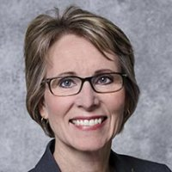 | Nancy Fahrenwald, Chair | Dean, College of Nursing
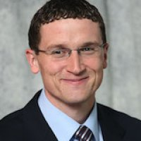 | Dr. Dan Hansen | Assistant Dean for Student Services – College Leadership Team
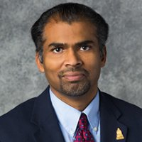 | Dr. Om Perumal | Department Head, Pharmaceutical Sciences – College Leadership Team
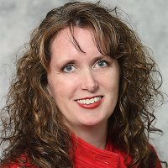 | Dr. Jodi Heins | Assistant Department Head of Pharmacy Practice – College Leadership Team
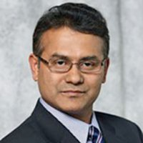 | Dr. Shafiqur Rahman | Professor of Pharmaceutical Sciences – Pharmaceutical Sciences Faculty
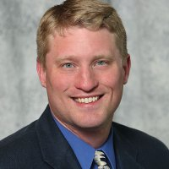 | Dr. Brad Laible | Professor of Pharmacy Practice – Pharmacy Practice Faculty (Eastern SD)
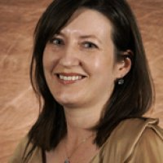 | Dr. Wendy Jensen Bender | Professor of Pharmacy Practice – Pharmacy Practice Faculty (Western SD)
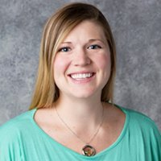 | Ms. April Nelsen | MLS Program Instructor – MLS Program Faculty
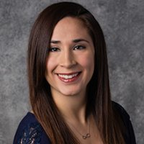 | Ms. Tiffany Montalvo | Laboratory Support Specialist – College Staff
 | Mr. Chris Kotschevar | PharmD Program Student – Student Representative
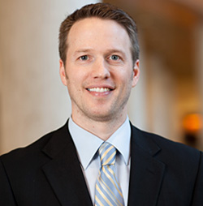 | Dr. Garrett Schramm | Director of Pharmacy Education & Academic Affairs, Mayo Clinic – External Stakeholder/Advisory Council

