



Blackboard Transact Mobile eAccounts Application

for Android

Install Guide

Contents

1.INSTALLING eACCOUNTS APP

2.SEARCHING FOR SOUTH DAKOTA STATE UNIVERSITY

3.LOGGING INTO THE eACCOUNTS PORTAL

4.HOME SCREEN

**1. INSTALLING eACCOUNTS APP**

To install the eAccounts mobile application on your Android device and search for "Blackboard Transact Mobile eAccounts". Install the application on your device by clicking on install button in the Google Store.

Figure 1.1

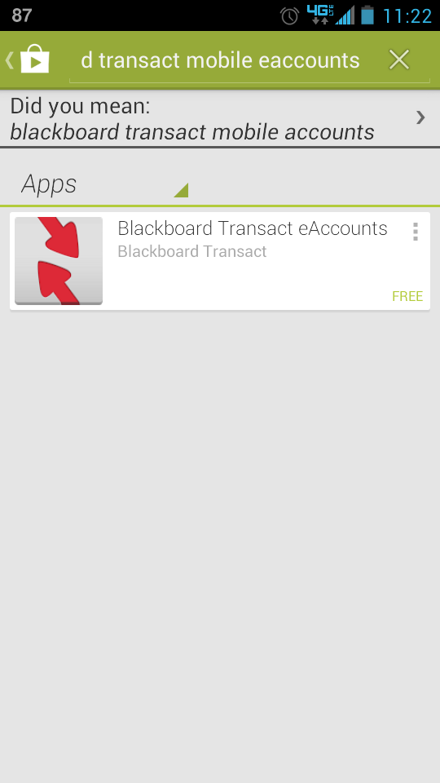 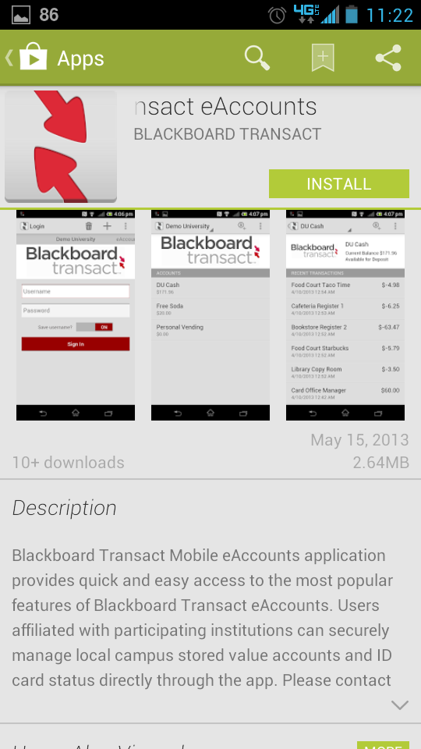

**2. SEARCHING FOR SOUTH DAKOTA STATE UNIVERSITY**

After installing Blackboard (Bb) Transact to your Android device, tap the eAccounts icon to open the application. Select Add a Site. Select South Dakota State University from the initial screen; by scrolling through the list or entering "South Dakota State University" in search value to find the school. A sample search screen is shown below.

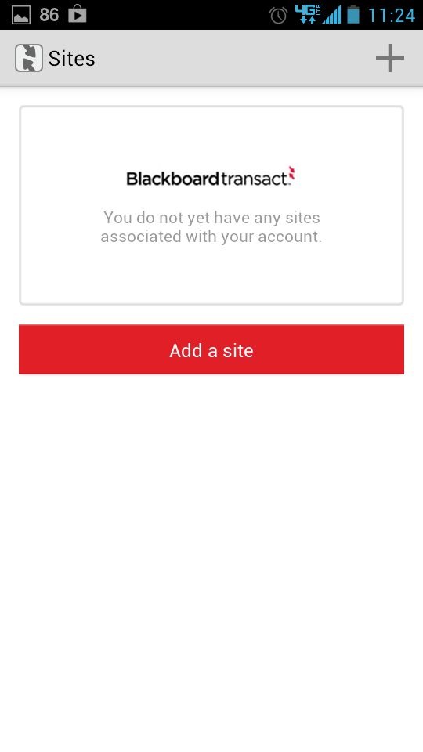 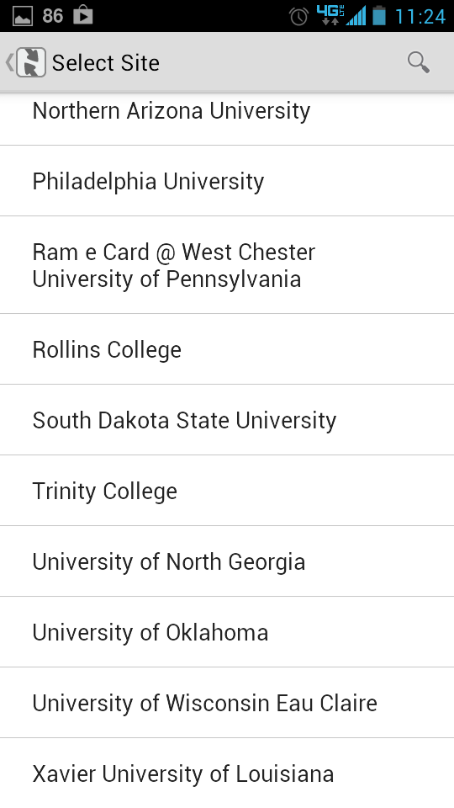

Fig 2.1 Select site

**3. LOGGING INTO THE EACCOUNTS PORTAL**

After selecting the South Dakota State University Site, click on SDSU Login. Now the South Dakota State University eAccounts selection is configured in your device. Following the selection of the login method, a screen displays for sign-in as shown below. On subsequent uses of the application, the login screen automatically displays. Enter your South Dakota State University Username and Password exactly as you would when using the eAccounts web page and hit SIGN IN.

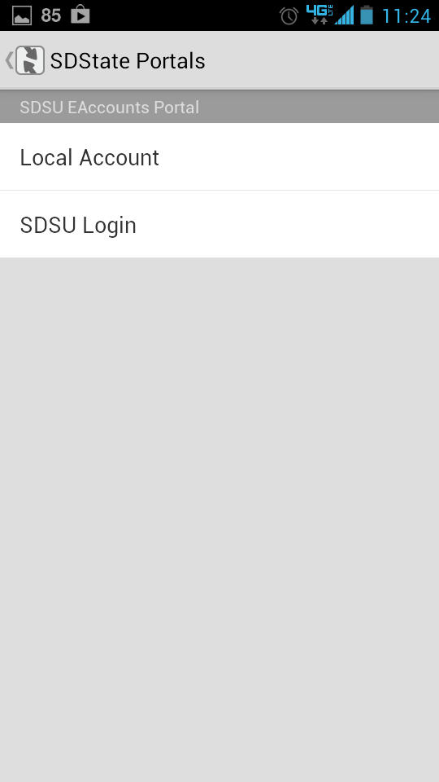 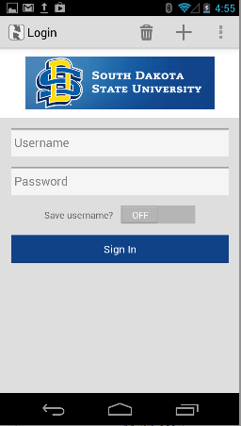

Figure 3.1 select SDSU Login and Sign on Screen

**4. HOME MENU**

The Home screen displays a list of your current accounts and balances. A sample summary screen is shown below

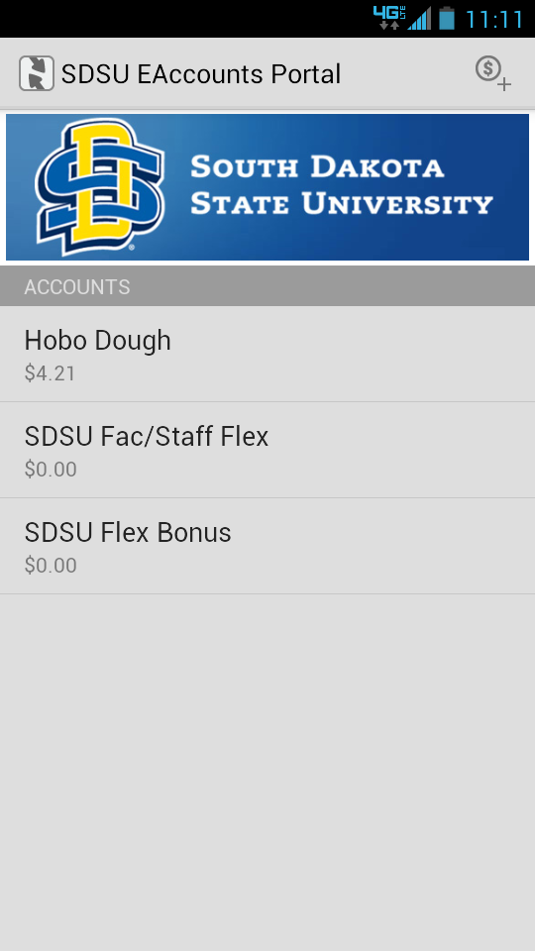

Figure 4.1 Home Screen