|  |  |  |
| --- | --- | --- |
|  | South Dakota View Consortium Overview  2014 - 2015 |  |
|  |  |  |

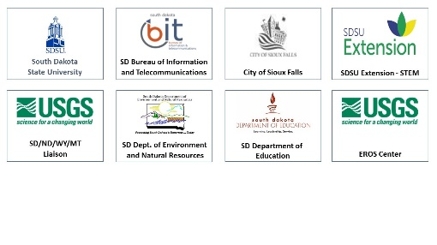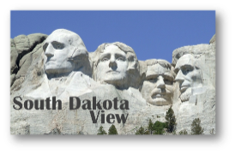

**Enhancing the Understanding and Use of Remote Sensing in South Dakota**

**Consortium Membership**

**South Dakota View (SDView) Overall Vision*: Building partnerships and capability within South Dakota to facilitate the utilization of remote sensing data and geospatial technologies for the benefit of its citizens and the economic development of the state***

**SDView Long-Term Goals:**

1. ***Develop the SDView consortium such that it meets the needs of South Dakota and participates synergistically within AmericaView, Inc.*** SDView provides a mechanism for coordination and sharing of geospatial activities and data in South Dakota and provides connections via AmericaView to expertise outside of the state.
2. ***Provide access to remote sensing data for South Dakota.*** SDView provides a gateway to Landsat, MODIS, NAIP, and other imagery and to imagery download services such as GloVis and EarthExplorer.
3. ***Expand the knowledge and utilization of remote sensing via courses, workshops and other educational opportunities for K-12 educators, university students and the existing workforce.*** SDView provides workshops and course materials for K-12 educators, university students, agricultural producers, extension educators, and the general public. SDView also continues to promote the expansion of the number of courses at South Dakota universities, tribal colleges, and technical institutes that include remote sensing as all or part of the content.
4. ***Support remote sensing research at research universities in South Dakota through access to data and, as funding becomes available, through grants and contracts***. SDView facilitates remote sensing research activities by providing access to remotely

sensed data and by demonstrating practical applications of geospatial technologies.

1. ***Build partnerships with state and local government entities that explore and test the utility of remote sensing data products for practical applications that will benefit the citizens of SD.*** SDView will continue to serve as an effective mechanism for disseminating information about remote sensing data and applications to local, state and federal agency personnel in the state, as well as to private industry.

The SDView mission of **expanding the utilization of remotely sensed imagery and technology for the benefit of its citizens, scientists, researchers, and educators** is accomplished via a consortium of partners from throughout the state. The entities below in addition to many universities, technical institutes, and tribal colleges in the state have worked with SDView in a variety of activities that further the vision, mission and goals of SDView.

**http://sdview.sdstate.edu**

*Federal consortium members identified above do not receive funding from AmericaView.*

**AmericaView Website:**   
[www.AmericaView.org](http://www.AmericaView.org)

**Roberta Lenczowski, Executive Director:**[roberta.lenczowski@sbcglobal.net](mailto:roberta.lenczowski@sbcglobal.net)

**Debbie Deagen, Program Manager:**[debbie.deagen@montana.edu](mailto:debbie.deagen@montana.edu)

**Russell Congalton, Board Chair:**[russ.congalton@unh.edu](mailto:russ.congalton@unh.edu)

|  |
| --- |
| **South Dakota View Principal Investigator:** |
| **Mary O’Neill** |
| **South Dakota State University** |
| **605.688.5597** |
| **mary.oneill@sdstate.edu** |