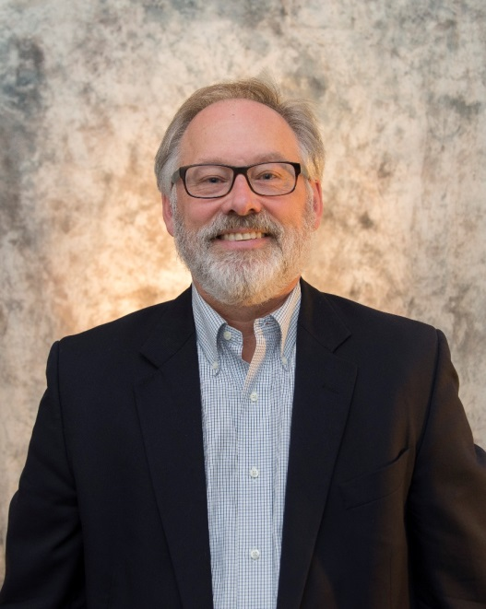**Dr. Daniel T. Lichter**

**Title**:  “Children at Risk:  Racial Diversity, Poverty, and the American Future”

**Background:**

Dr. Daniel T. Lichter is the Ferris Family professor in the Department of Policy Analysis and Management, Professor of Sociology, and Director of the Cornell Population Center. He also is the Robert S. Harrison Director of Cornell's Institute for the Social Sciences.  He received his Ph.D. in Sociology in 1981 from the University of Wisconsin-Madison.  He is past president of the Population Association of American and the Rural Sociological Society.  He recently served as a panel member of the National Academy of Sciences panel on “The Integration of Immigrants in the United States.”  Lichter is a Mitchell, South Dakota native and received his B.S. from South Dakota State University in 1975.

**April 14, 1:00 p.m. Location TBD**

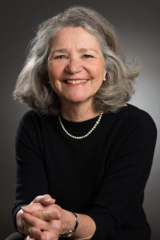**Dr. Mil Duncan**

**Title**: Rural Communities: Building a Future in the Shadow of the Past

**Background:**

Mil Duncan is a sociologist whose work has focused on rural poverty, social change and development.  She is the author of Worlds Apart: Poverty and Politics in Rural America (updated in 2014). She is a fellow Carsey School of Public Policy and Professor Emerita Department of Sociology at University of New Hampshire

**April 14: 7 p.m. Location TBD**

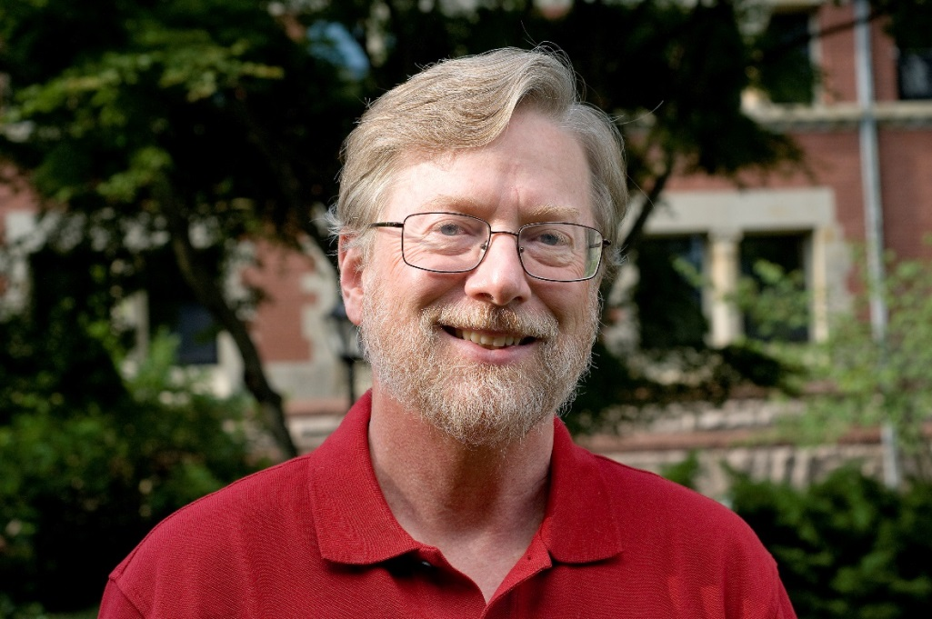**Dr. John Logan**

**Title:** the geography of opportunity in rural schools

**Background:**

Dr. John R. Logan is Professor of Sociology and Director of the initiative on Spatial Structures in the Social Sciences at Brown University.  He is co-author, along with Harvey Molotch, of *Urban Fortunes: The Political Economy of Place*. His most recent edited books are *Urban China in Transition* (Blackwell 2007) and *Diversity and Disparities: America Enters a New Century*  (Russell Sage Foundation 2014). He has undertaken studies of neighborhood change and individual mobility in U.S. cities in the period 1880-1940, and in recent times. Since the early 1990s, he has studied social change in China, especially impacts of market transition. He is also continuing research on the impact of hurricanes in the Gulf Coast, on racial inequalities in public education, and housing segregation.

**April 15: 1:00 p.m. location TBD**